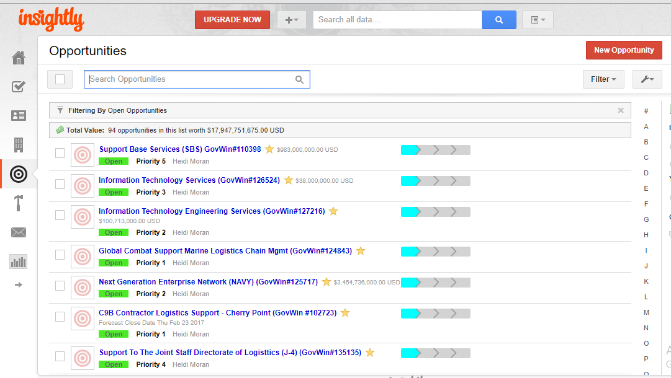
- Once I login, I land into the home page (shown above) which has many icons and features, however; for now and for what we are trying to do with this project we can have a sidebar or top menu with the following features: (1) opportunity and (2) contact icons, (3) an add button (to add a new opportunity or contact), (4) recent activity (as shown below), and (5) the search bar (if possible). Note: There is another feature for users to add a company profile, same as the contact but for the entity but for now if that’s too much work, with the opportunity and contact information, we should be good.

The image below shows you what is displayed to the user once the recent activity button is clicked.

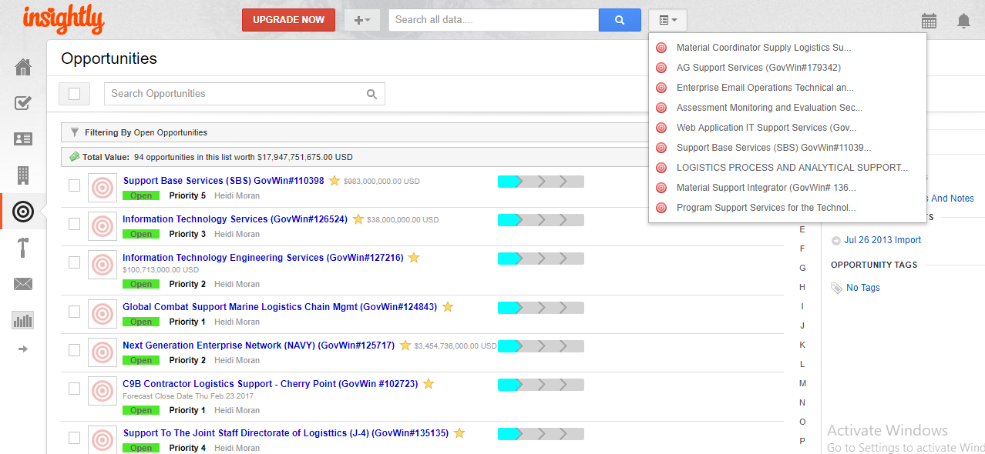

- Once I click on the opportunity icon, the list of the opportunities comes up. I am not sure what order Insightly uses, but if you look at the image, they are kind of scattered, priority 5,3,2,1 as opposed to showing it in a more organized manner and having it by groups/sections in which all opportunities labeled Priority 5 should be on the top since those are the ones that we are more interested in and Priority 1 at the bottom.

- Adding a new opportunity: Click on the New Opportunity button or the Add button and select “Add New Opportunity”.

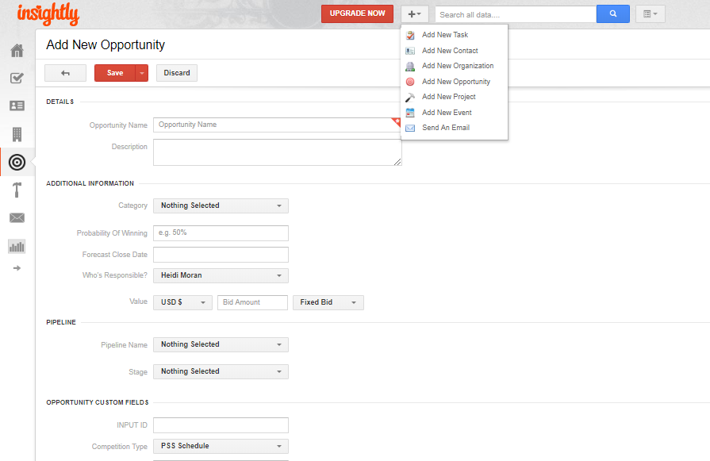

Once you arrive to the Add New Opportunity page, the following fields appear on the screen. I had to split it into two images so you guys can read it.
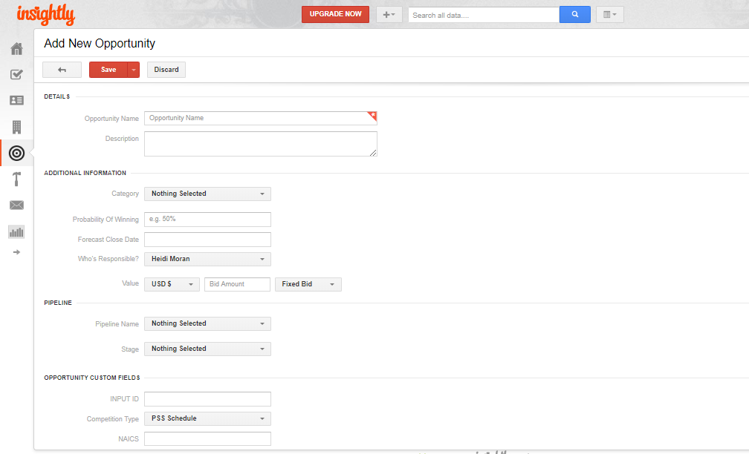
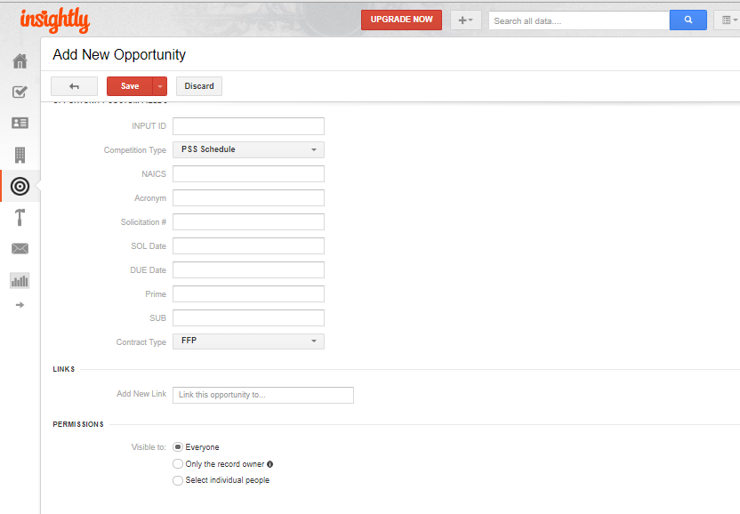
Once you add the information simply click on Save, to save your work.

- Adding a contact is very similar to adding an opportunity but with different fields. Notice they are sorted in alpha. See images below:

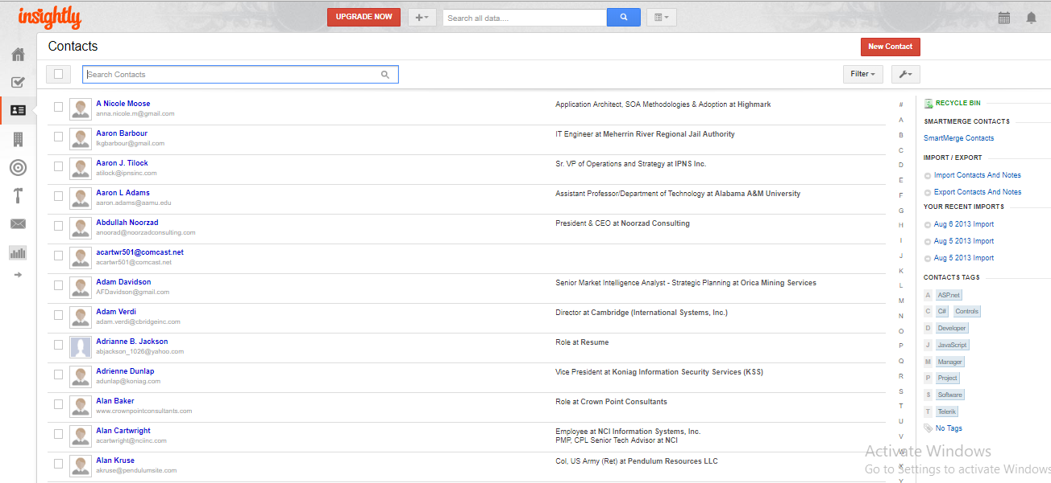
Click on either of these two to add a contact.
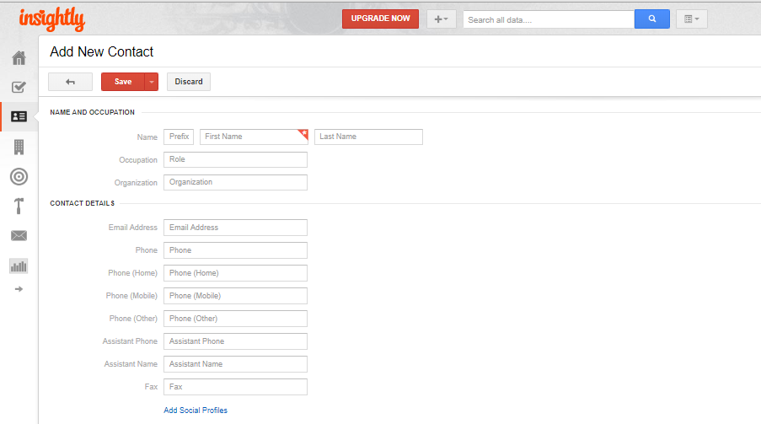
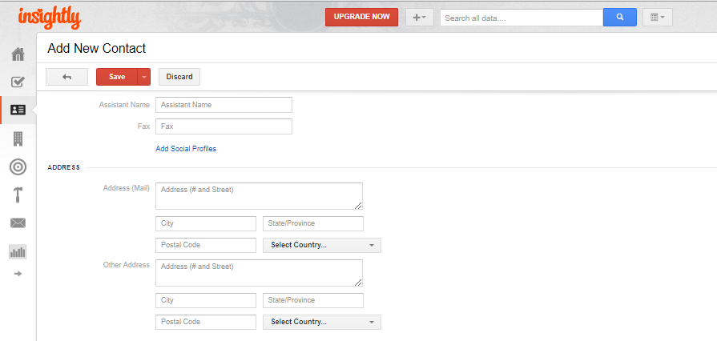

For what we want I think we only need to have the following fields on this section:
- Last Name
- First Name
- MI
- Name of Organization they belong to
- Role/Position
- Email
- Phone Number (if applicable)
- Address (If applicable)
- Fax (If applicable)

- I am going to show you what information is displayed on GovWin. GovWin is the tool we use to find and capture new
opportunities.

